**Assignment 2 – Biological Weapon Fallout**

**Background**

Bacteria_bomb is an agent base model that illustrate the scenario of a terrorist attack, particularly a bomb that has released harmful bacteria within an area, known to be deadly if in human contact. The logical code written takes 5000 agents (each agent depicting a bacterium), and moves them randomly, dependent on the probability of what cardinal direction the wind will blow it towards, and whether it touches the ground or not as the bomb is stationed on top of a 75m meter high building. A class method has been created to help move the agents from the starting location (bomb point), to where it is most likely going to end up.

A move function was coded to calculate whether each agent should move 5% West, 10% North/South or 75% East. Subsequently, a height function was coded to simultaneously run with the move function to determine whether the bacterial agents will land on the ground or not. Thus, each agent's location is then plotted to a graph to distinguish the overall density of the contamination. The density map will then support the government’s anti-terrorist department throughout the process in ascertaining where the bacteria has spread to, and deal with the matter accordingly.

**Development process and software design method used**

In order to start coding the model, a software development process was needed as a guide to manage the structure and produce an interconnecting flow of code. Thus, the waterfall methodology was chosen and utilised to help initiate each step to complete the agent base model. Such methodology is a linear project management framework which focuses on the requirements needed to complete a project, before following sequential steps to accomplish the established requirements (Waterfall Methodology in Project Management 2019). Figure 1 depicts the framework of the waterfall methodology. The project includes the process of analysing the steps and data listed in the project brief, then logically writing and testing different coded statements until each step was successfully coded.

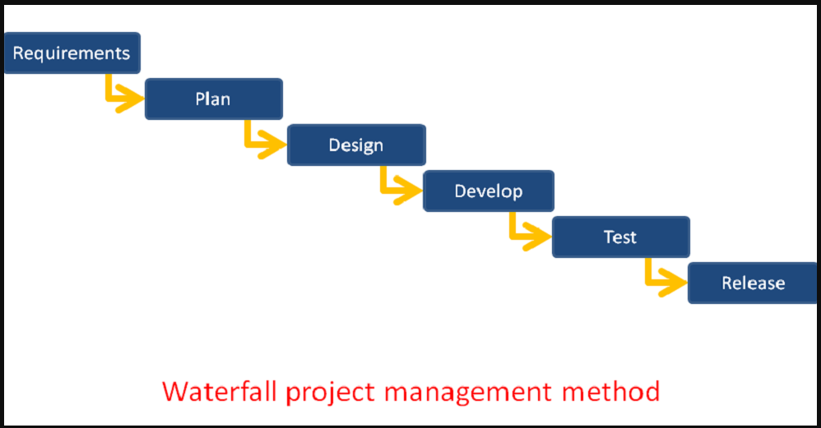

# *Figure 1: waterfall methodology (Waterfall project management- A tutorial, 2019).*

**Errors encountered and debugging**

***Error 1***

A for loop was created to append the location of the bomb into a separate list from the environment file (wind.raster.txt). However, the initial for loop created produced a list of the environment’s binary position numbers followed by several empty brackets. To solve this error, an enumerate function was used to read through the environment’s list index position and values, to then append the location of the bomb to an empty list. Such method was also a tidier approach in comparison to the “range(len” method, as less lines of code are used (Enumerate() in python n.d).

***Error 2***

Whilst testing to ascertain if the spread.py produced an x and y variable from the Agent Class method, the following error appeared “a = spread.Agent() TypeError: __init__() missing 3 required positional arguments: 'environment', 'bacteria', and 'bomb'”. To solve this, the environment, bacteria and bomb variable names was added to the print syntax (line 54) to call the function to the main model.

***Error 3***

The spread and height function that determines the direction and ground level of the agents produced the results “None” when ran to test if the calculations worked. To correct this issue, the code “environment[bacteria[i].y][bacteria[i].x] += 1” needed to be indented in line with the while loop as opposed to outside the loop.

***Error 4***

Lastly, the graph that depicts where the bacterial agents will end up appeared to have placed the results at the wrong location. Figure 2, evidence a small cluster to the North West of the bomb’s location, however, the likeliness of the bacterial agent being blown West are slim in comparison to the wind directing it East (75% likely) and North and South (10% likely).

The issue identified was with the for loop as it read in the bomb inversely because the code instructed python to read the y value before the x value. The issue was fixed by swapping the coordinates to read the x coordinate before the y coordinate. Now, the results are places to the East of the bomb, which is the most probable outcome.

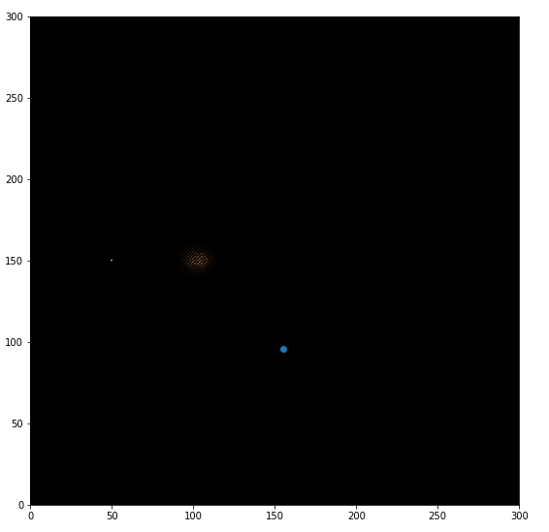

*Figure 2: Erroneous Bacterial agents density map.*

**Bibliography**

GeeksforGeeks. *Enumerate() in python.* [Online]. [Accessed 29th August 2019]. Available from: [https://ww https://www.geeksforgeeks.org/enumerate-in-python/w.islington.gov.uk/~/media/sharepoint-lists/public-records/environmentalprotection/qualityandperformance/reporting/20112012/20120303chapter6sustainabletransport](https://www.islington.gov.uk/~/media/sharepoint-lists/public-records/environmentalprotection/qualityandperformance/reporting/20112012/20120303chapter6sustainabletransport)

ProjectManager. Waterfall Methodology in Project Management. [Online].[Accessed 24 September 2019]. Available from: <https://www.projectmanager.com/software/use-cases/waterfall-methodology>

Binfire. Waterfall project management- A tutorial.[Online]. [Accessed 23rd September 2019]. Available from: <https://www.binfire.com/blog/2017/04/waterfall-project-management-tutorial/>